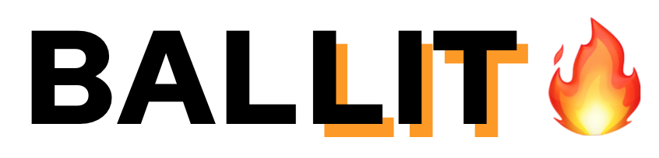

# 

# 

# **VALUE PROPOSITION**

To streamline political information and empower young voters to shape their futures.

# **PROBLEM AND SOLUTION**

Currently, political news outlets are not targeting young consumers. As a result, Gen Z feels lost, disillusioned, and cynical about politics. They are overwhelmed by the constant barrage of news. They need a fun, accessible way to learn about policies and organize their views. We propose a simple application, BALLIT, that has features (social media memes, emojis, Tinder “swiping”) that make politics feel fun and young. Our solution helps young voters understand what policies matter to them and learn more about upcoming elections.

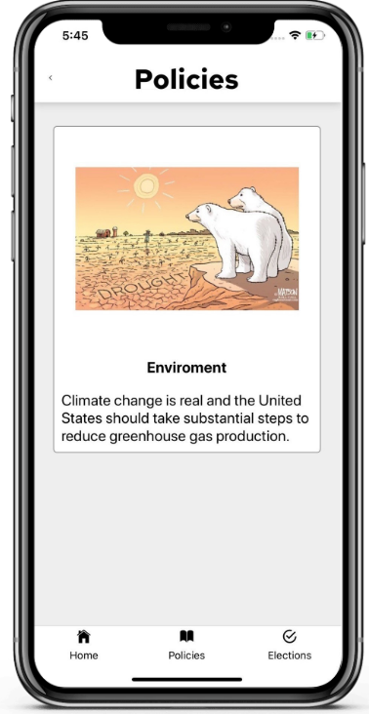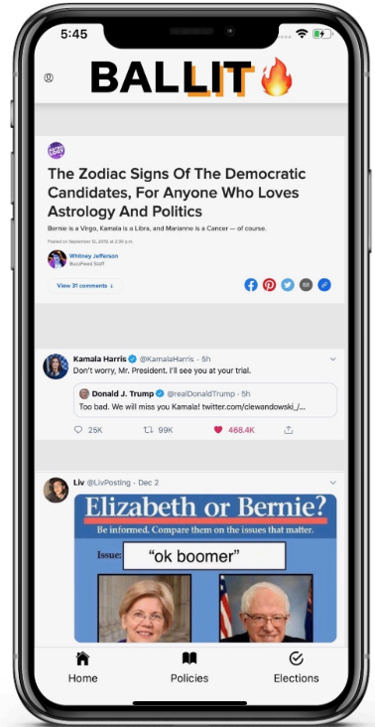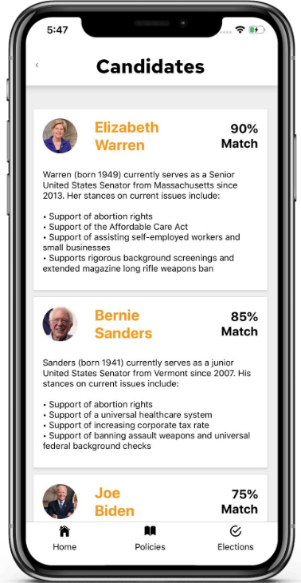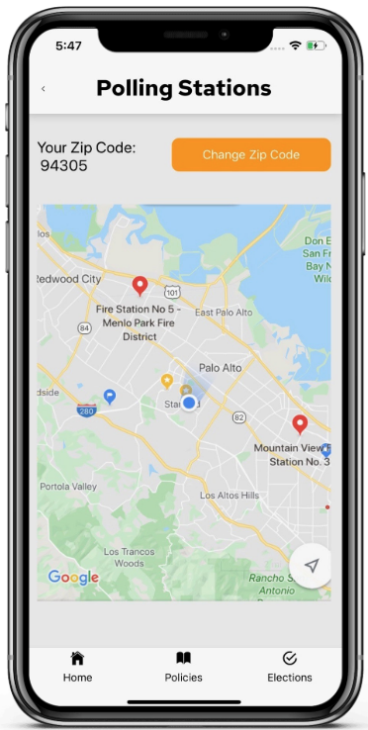

# **TASKS**

In order of increasing complexity, our three tasks for BALLIT include:

**Find Polling Locations:**

We originally came up with this task as a potential idea for a wearable. However, with more thought, we thought that this task is still useful for a mobile app. Young voters, with busy schedules, wouldn’t think to look up the nearest voting location on their own accord, especially without an educational app like BALLIT. We integrated it into the election page, because that is the last step of the voting process once the user has chosen their candidates and stances on propositions.

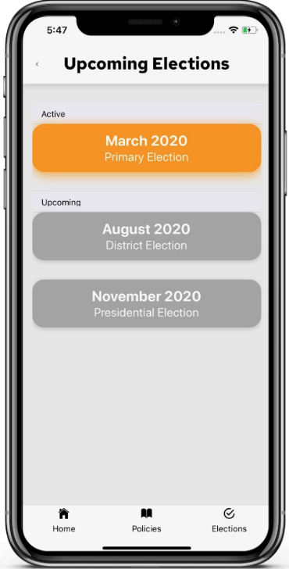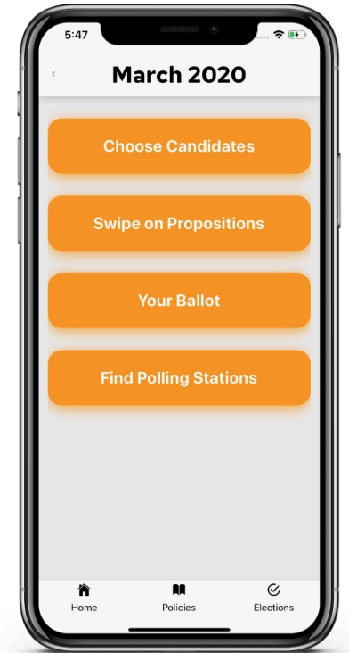

**Swipe on Policies:**

This task was the original idea of our app. Since young voters tend to be uneducated on what are the main voting policies in today’s government, we definitely wanted that information to be on this app. Furthermore, we wanted the users to be able to decide where they stand in terms of these issues, so we wanted to include education on the beliefs of the major parties regarding each policy. Users can swipe on whether this policy interests them or not, a choice that we deemed more fun and youthful, reminiscent of a popular app like Tinder.



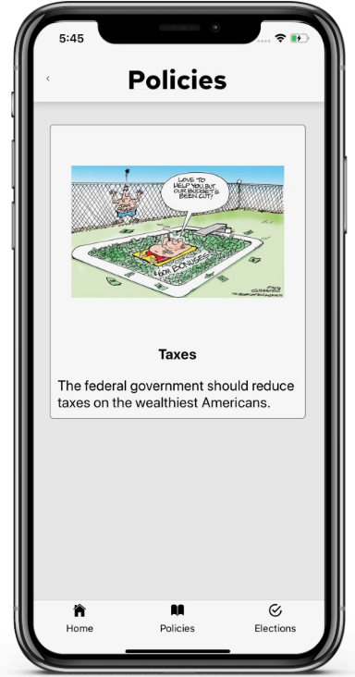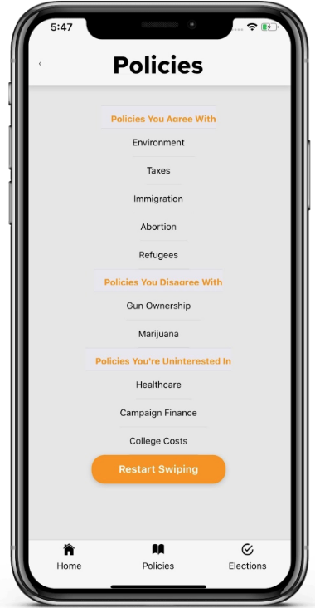

**Discover Candidates:**

Finally, we included discovering candidates as our final task. We wanted users to be able to “understand their ballot,” which included possibly sorting through a long list of candidates. We wanted our app to make this choice easier, based on the policy choices that the user has made. This task is a little more complicated because it includes analyzing each candidate and finding the best match for the user, along with presenting information so the user can make the best, most informed choice.

# 

# 

# **DESIGN EVOLUTION**

**Initial Sketches:**

Our initial sketches played around with different tasks, because we hadn’t exactly decided what they were going to be. We thought that swiping on policies might lead to candidates that may be appealing to the users. We abandoned that idea, because of the several different options for candidates. One initial idea here is a policy being represented as a specific proposal. We abandoned this idea in our later prototypes, but decided to bring back the specificity for our high-fi.

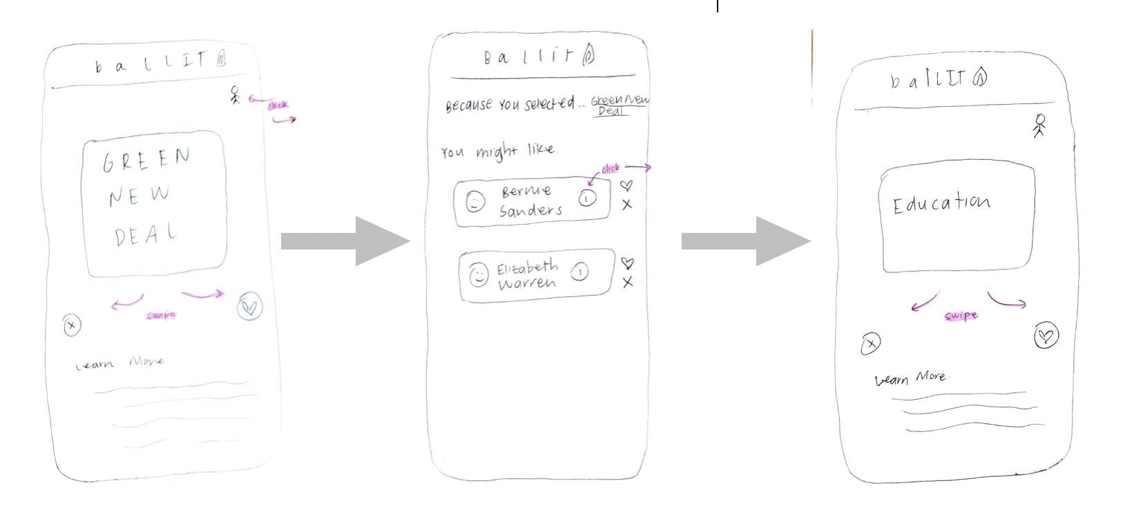

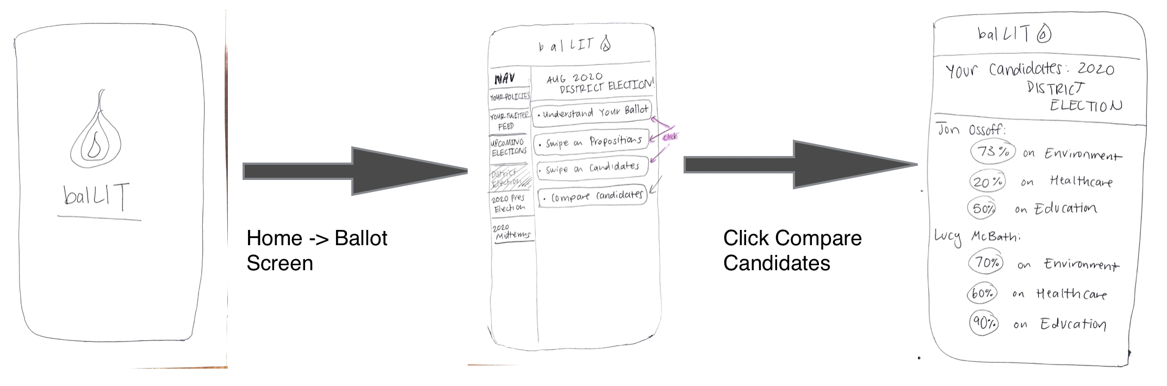

Here we had an idea about comparing candidates, which we decided to compress into our task of choosing candidates, and remove the swipe function of that task.

**Low-Fi Prototype**

To create this low-fi prototype, we created a fake iPhone, and placed cards on it to simulate different screens.

These designs reflect some ideas that have since been abandoned, such as a swipe on candidates task, where the user chooses between the candidates running for a certain election. Again, we abandoned this idea because of the option of multiple candidates running for an election, as well as making the choice of candidate be more informative and thought provoking, instead of quick and swipeable. The task of swiping on policies remained almost the same; we chose to instead have specific stances for a certain policy be swiped on instead of the policy as a whole. This allows for specific data to be collected about the user, and a faster process for choosing policies that interest them. 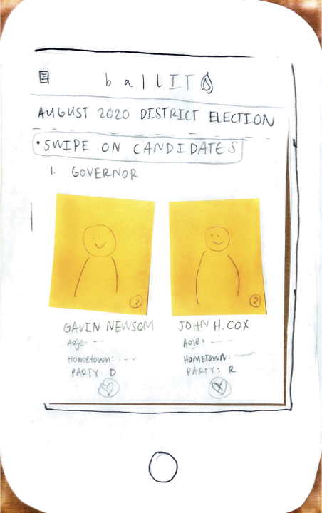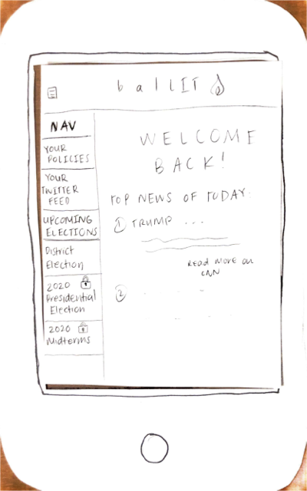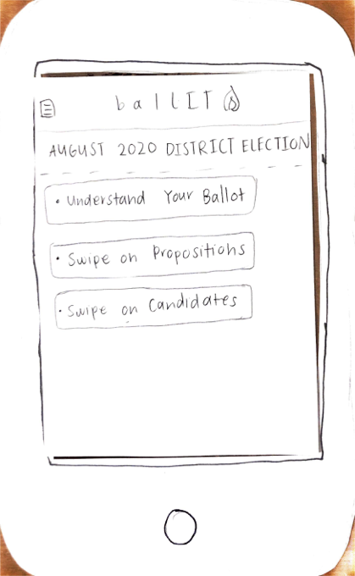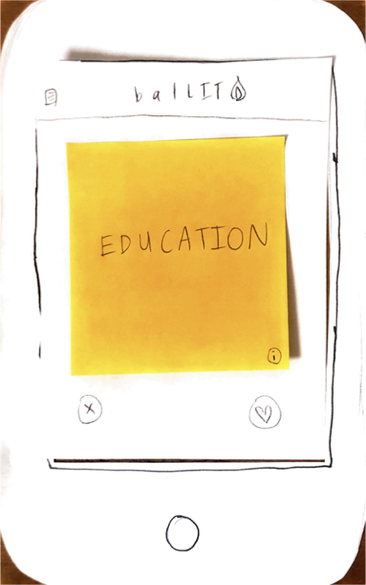

We also changed the idea for the home screen of the app, based on the feedback given in class. At first, we thought that it might be useful to have top news of today be the first thing that a user looks at, which may also encourage continuous use. We decided to change the home screen to be popular political memes and tweets to emphasize the “Gen-Z feel” and humor associated with the app.

**Medium-Fi Prototype**

Using Figma, we constructed our medium-fi prototype by implementing the three main tasks that we wanted, including the home screen.

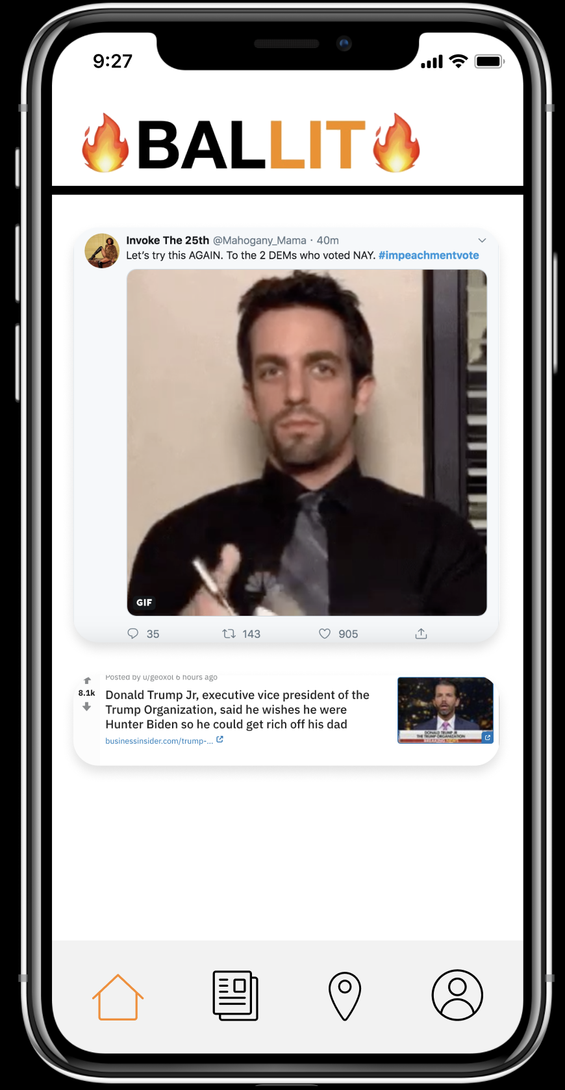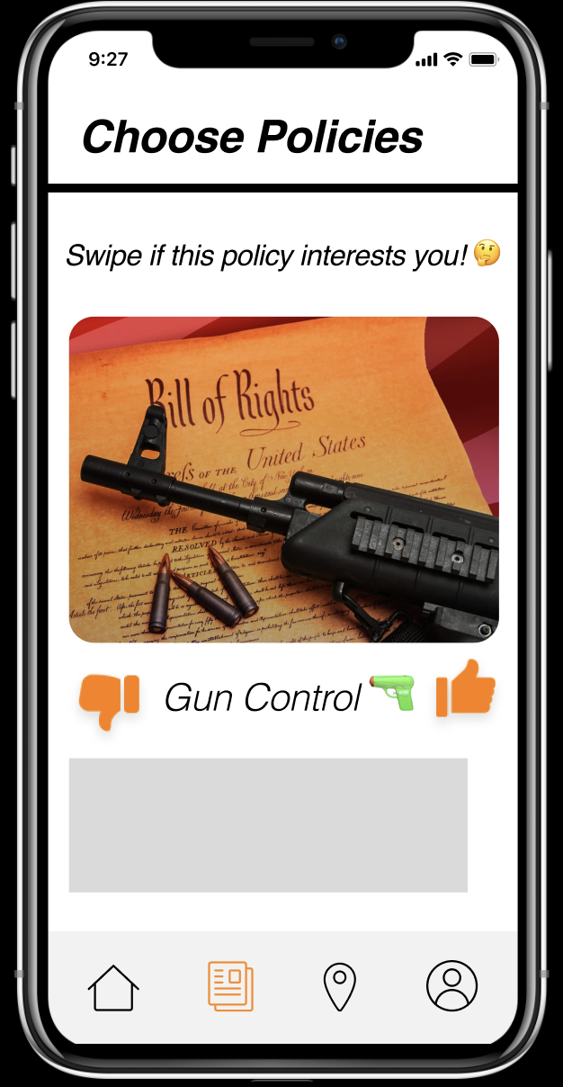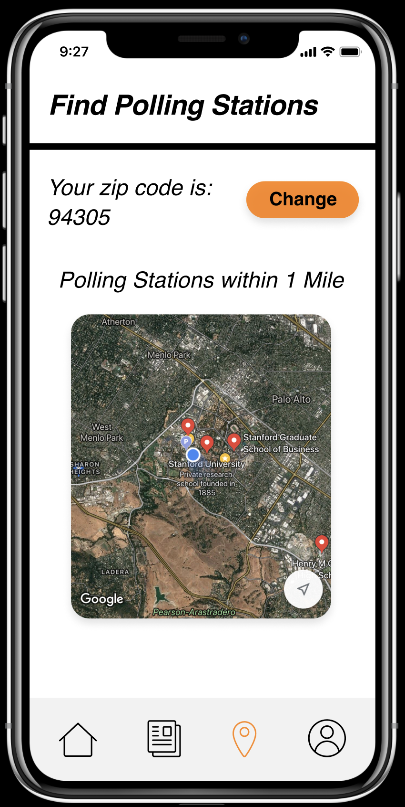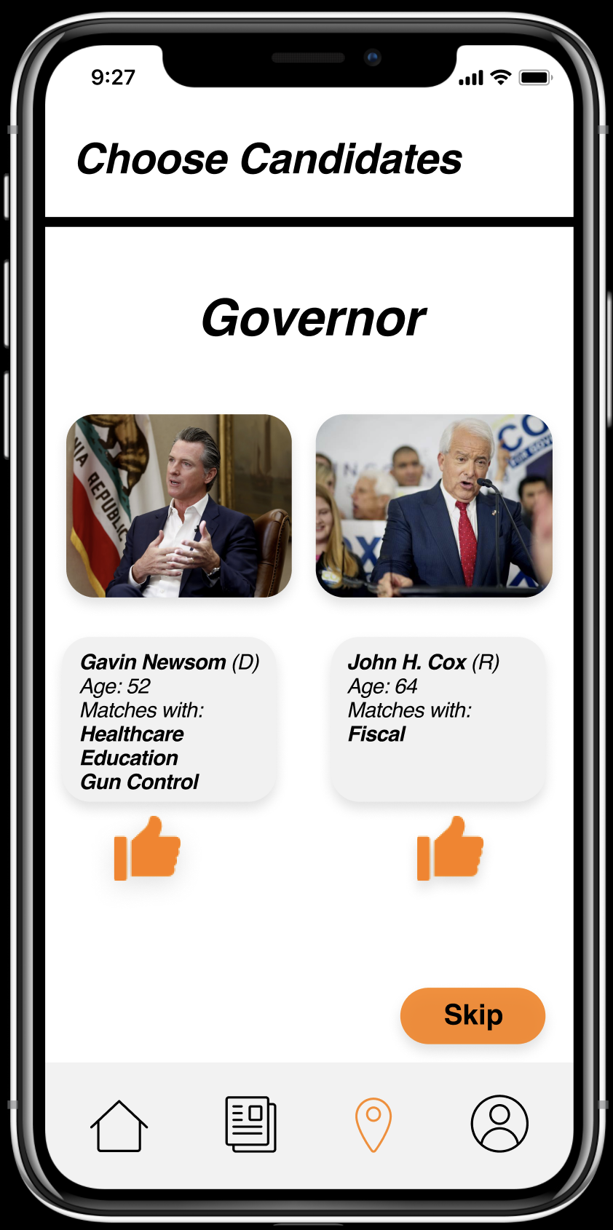

These prototypes were significantly different from our low-fi design, because we switched the navigation to be at the bottom to signify our main tasks and a profile for the user. We implemented the switch to swiping on policies and choosing between candidates, and the home screen.

This design differs from our final prototype in a few ways, based on our heuristic evaluations. We changed the icons and design of our bottom bar navigation to include text, to be more specific in what the user was clicking on.

This design also differs in the way we represent the policy swiping. Instead of using emojis and pictures, we decided to use political cartoons to keep the humorous theme.

# **USABILITY PROBLEMS ADDRESSED**

We had 8 heuristic violations of severity 3 and 4:

1. **H10 Help and Documentation (Sev: 3)**

Icons on the bottom are misleading as to what screens they will bring. The location symbol suggests an interactive map, while the paper symbol does not clearly convey policies. It lacks clear instruction.

**Fix**: Use small text to display the destination of the buttons or change the icons.

We agreed that the icons were not capable of fully encapsulating the actions within that tab. For this violation, we decided to abandon the icons we originally chose for our app, and use text instead. We also didn’t need a profile icon in our navigation this time



1. **H4 Consistency and Standards (Sev: 4)**

When expressing interest or disinterest in certain policies, the instructions say to swipe if you are interested, but the interface displays ‘like’ and ‘dislike’ buttons for the user to click. Users may be confused as to the conflicting instructions.

**Fix**: Choose one method (either liking or swiping) and stick with it.

For this violation, we decided to stick with swiping. That was our initial idea for the app, so we wanted to maintain that youthful activity for this task.



1. **H3 User Control and Freedom (Sev: 4)**

If the user makes a mistake in liking or disliking a policy, there is no way for them to return to the screen. While this feature is appealing for Tinder, where excitement is key, it is not desirable when selecting on which topics you want to receive news. No screens have back buttons.

**Fix**: Add a ‘Back’ button to every screen

To address this violation, we included a back arrow on every screen that could go backwards to a previous screen.





1. **H1 Visibility of System Status (Sev: 3)**

Once you finish the policy selection, it is unclear what happens. Are you returned straight to your home newsfeed? If so, what is the difference in the newsfeed? There is no detail as to what was achieved.

**Fix**: Label a button ‘Submit’ that clearly redirects to a changed home screen

For this violation, we used cards that redirect to a summary page once the swiping is all completed. 



1. **H7 Flexibility and Efficiency of Use (Sev: 3)**

There is no way to change preferences over time without swiping through all of them again. This does not allow for user preferences to change and easily be updated.

**Fix**: Use the profile page to easily alter preferences.

For this violation, we decided to avoid the specific policy changes, and instead offer a way to swipe on policies all over again. We thought that easily altering preferences would be a good feature of a profile page, but we did not have the ability to create a profile page with that functionality.



1. **H6 Recognition Rather than Recall Sev: 3**

Users cannot access their preferred candidates in order to reference what choices they made before. This may confuse the user should they not recall.

**Fix**: Allow users to access their saved choices in order to create their profile.

With our design change, this would not be an issue where the user needs to save their choices. Instead, they are discovering candidates in the election in order of best match, and can always access that page once again.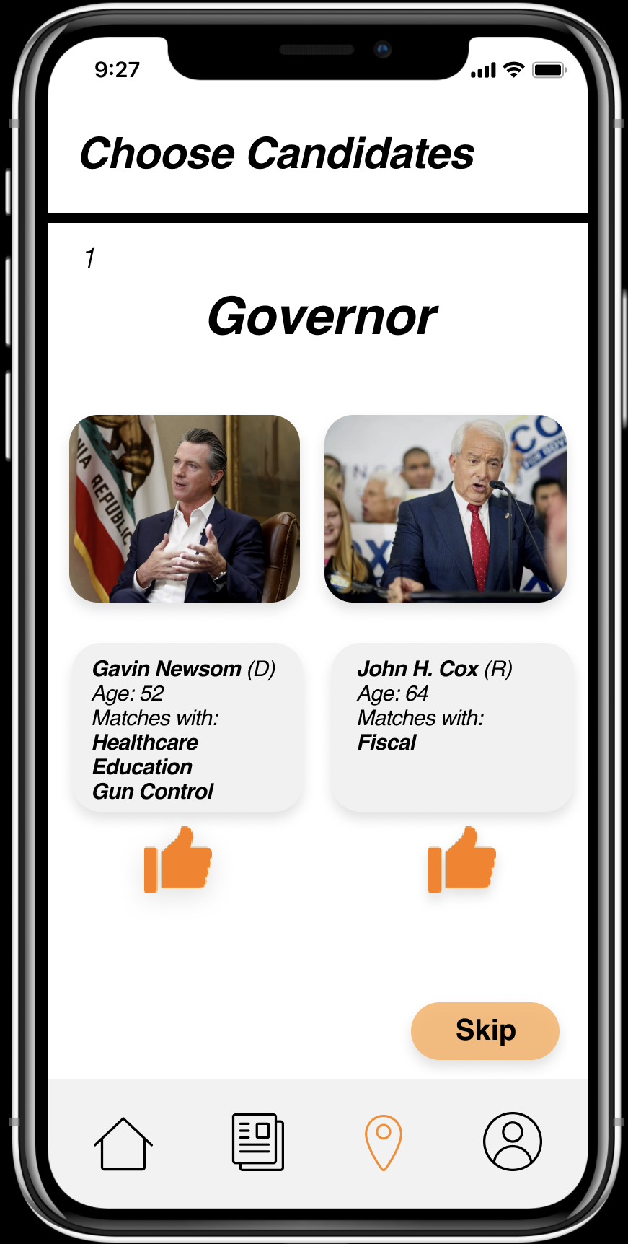

1. **H1 Visibility of System Status Sev: 4**

The user cannot see all the information on the candidates, merely if it is a match on certain subjects. I feel like this is a dangerous way to tell voters what candidate they should vote for, using a matching algorithm to influence them. It seems to take a lot of agency away from the voter.

**Fix**: Let the user access all the candidates’ information by clicking on each profile instead of matching them based on their policy preferences.

Instead of having just the match percentage, we decided to include the main stances of each candidate as well, to address this heuristic. However, an important aspect of this app was to make politics less time intensive and more inclusive for youth. Having an immediate match gives the user the best idea of who best aligns with their views if they do not intend on doing further research.



1. **H1. Visibility of System Status Sev: 4**

When going through the Choosing Candidates cards, clicking the thumbs up on either gubernatorial candidate brings the user back to the Election options menu. There is no indication of what the clicking thumbs up button did. This is also true for the policy cards.

**Fix**: A message should pop up, notifying the user of what the clicking the thumbs up button did, whether it saved the candidate or gave more information about the candidate

For this violation, the policies were addressed by the messages “I agree,” “I disagree,” and “I don’t care” when the user is swiping on the policies. For the choosing candidates cards, we decided to have it be informational as opposed to a selection.

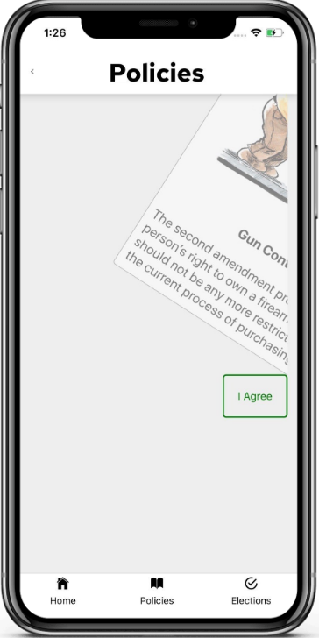

# 

# 

# 

# 

# 

# 

# **PROTOTYPE IMPLEMENTATION**

Our high fidelity prototype was built using React Native. React Native was the simplest iOS development tool that we could learn, considering none of us have any experience with mobile app development. React Native allowed us to download different packages and templates that are online that we could tweak to serve our purposes. Because React Native is component based, it was significantly more simple to piece together the buttons and features that we wanted to include.

We had to overcome a steep learning curve to get the app together in the short time frame that we had, considering none of us were developers at the start of the quarter. Specific features that we wanted were hard to exactly replicate the way that we envisioned them looking like. Existing templates were difficult to modify to fit our vision.

We did not use any Wizard of Oz techniques for our app, since we did not need any human response in our tasks.

We hard-coded many features in the app, due to limitations in our knowledge of React Native. We put in the memes for the home page, the list of policies that the users can swipe on, elections, polling station GPS, and candidates for this election. We also hard-coded which choices the user makes in this iteration of using the app.

# **SUMMARY**

To summarize, BALLIT is a mobile application designed to get Gen Z involved in the political process. Based on needfinding interviews, BALLIT has been conceptualized to be as simple and fun as possible, as opposed to the barrage of information that current news sources provide today. Our goal was to empower young voters into shaping their own future.

The process of creating BALLIT took different twists and turns, but in the end, we came up with three tasks: Swipe on policies, discover candidates, and find polling locations. Each task allows for the user to personalize their politics, find out who represents them the best, and where they can get involved. We started our prototyping with mere paper, but eventually increased fidelity using Figma and React Native.

While the process had its challenges, we believe that BALLIT is a meaningful step forward in helping young voters get involved in politics. Thank you!